 | Filing Reference : |  | GG/COMS/TS.2/16
 | Document Title : |  | Use-Case Realization Report (Analysis)  Send Cylinder to a Particular Step
 | Version : |  | 1.0
 | Prepared By : |  | Koh Ming Jin
 | Date Created : |  | Monday, Apr 29th, 2011
Approved By :
 |  | Tran Ba Tien |  | Date
 |  | Project Manager |  | 29th Apr 2011
©2011 [Hoang Kim joint stock Company].
The information contained in this document is the property of [Hoang Kim joint stock Company]. The contents must not be reproduced, wholly or in part, for purposes other than for which it has been supplied, without the prior permission of [Hoang Kim joint stock Company], or, if it has been furnished under contract to another party, as expressly authorised under that contract. [Hoang Kim joint stock Company] shall not be liable for any errors or omissions.

Revision History
Date | Version | Description | Author
29/Apr/2011 | 1.0 | Initial Document | Koh Ming Jin

Table of Contents
1. Brief Description 4
2. Flow of Events 4
2.1 Standard Flow 4
2.1.1 Log-In 4
2.1.2 User Functions 4
2.1.3 Log-Out 4
2.2 Exception 5
3. Interaction Diagrams 5
3.1 Collaboration Diagram for Sending Cylinder to a Particular Step 5
4. Participating Objects 5
4.1 Operation Manager 5
4.2 Main Page 5
4.3 Role Main Page 6
4.4 Main Controller 6
4.5 Workflow Controller 6
4.6 Step Controller 6
4.7 Cylinder Controller 6
4.8 Error Controller 6
4.9 Step 6
4.10 Cylinder 6
4.11 Error 6
5. Class Diagrams 6
5.1 Domain Class Diagram: Sending Cylinder to a Step 6
6. Derived Requirements 7

Use-Case Realization Report
Send Cylinder to a Particular Step

Brief Description
This use case enables an Director, Department Manager and Operation Manager to send a cylinder to a particular process step.

Flow of Events
The standard flow of events for this use case and any exceptions are described in the following subsections. See section 3.1 for an overview of the participating Actors and Domain Objects.

Standard Flow
The flow of events is described as follows:

Log-In
To commence using the system, the Operation Manager is required to log-in successfully as follows:
- Refer to Log In Use Case for details.

User Functions
- The use case starts when Operation Manager selects the Send Cylinder to a Step option (operation sendCylinderToStep of MainPage) of the system. This will redirect to the RoleMainPage.

- The RoleMainPage will call the sendCylinderToStep operation of MainController .

- The RoleMainPage will retrieve the steps via the WorkflowController (operation retrieveSteps), which will communicate with StepController to retrieve the step objects (step 3-4).

- The MainController will retrieve the Error information via ErrorController using the operations retrieveAllErrors and getErrorDetails.

- The Operation Manager will enter the Cylinder code using either the barcode scanner or the keyboard (operation readInCylinderCode).

- The Operation Manager will select the next Step which the Cylinder needs to go to, using the operation selectParticularStep.

- The Operation Manager will select the error type for the Cylinder, using the operation selectErrorType.

- The Operation Manager will confirm all the information and submit the request using the operation confirmRequest.

- The RoleMainPage will call the MainController’s confirm operation and the Cylinder’s next step will be updated using the operations changeCylinderStep and updateCylinderNextStep of CylinderController and Cylinder object respectively.

- The updated information will be shown in the RoleMainPage

Log-Out
- The Operation Manager will terminate use of COMS (ie: log-out) by pressing a button with the caption “Log Out”.
- Refer to the Log Out Use Case for details.

Exception
- If the Error codes retrieval fails, an error message will be prompted to alert the user. The user will be asked to contact the administrator.
- If the Step information retrieval fails, an error message will be prompted to alert the user. The user will be asked to contact the administrator.
- If there is an issue with the update of the cylinder’s next step, an error message will be prompted to alert the user. The user will be asked to contact the administrator.

Interaction Diagrams

Collaboration Diagram for Sending Cylinder to a Particular Step
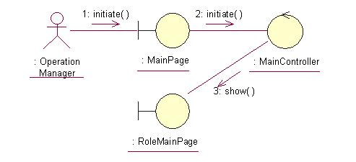
The above collaboration diagram shows the process flow after the actor has login.

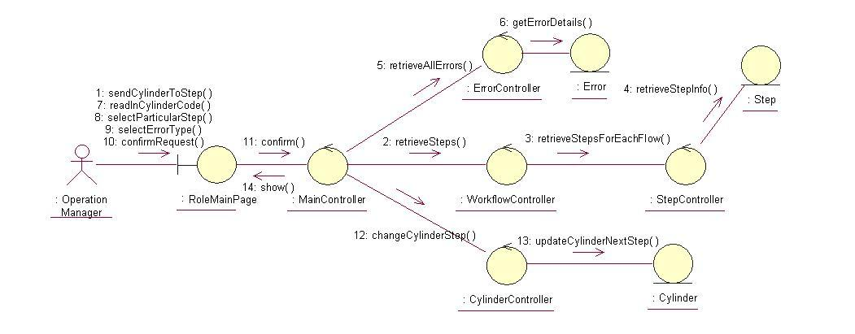
The above collaboration diagram shows the main process flow of this use case.

Participating Objects

Operation Manager
This actor represents the operation manager who will have a web page console to monitor and update the cylinder manufacturing operation.

Main Page
This object renders the contents after the actor has login.

Role Main Page
This object renders the contents (based on the user role) after the actor has login. The Director, Department Manager and Operation Manager actors use this object.

Main Controller
This object acts as the middleman between Role Main Page and the Error Controller, Workflow Controller and Cylinder Controller. It will translate interactions with the view into actions to be performed by the Error Controller.

Workflow Controller
This object acts as the middleman between “RerouteCylinder” Page and the Step Controller object. It will translate interactions with the view into actions to be performed by the Step Controller and Step objects.

Step Controller
This object acts as the middleman between Workflow Controller and Step object. It will translate requests by Workflow Controller into actions to be performed by the Step object.

Cylinder Controller
This object acts as the middleman between “RerouteCylinder” Page and the Cylinder object. It will translate requests by “RerouteCylinder” Page into actions to be performed by the Cylinder object.

Error Controller
This object acts as the middleman between “RerouteCylinder” Page and the Error object. It will translate interactions with the view into actions to be performed by the Error object.

Step
This object stores the details concerning the step information of the COMS.

Cylinder
This object stores the details concerning the cylinder information of the COMS.

Error
This object stores the details concerning the error of the COMS.

Class Diagrams

Domain Class Diagram: Sending Cylinder to a Step
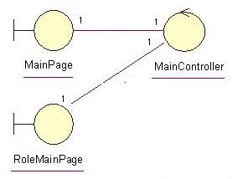
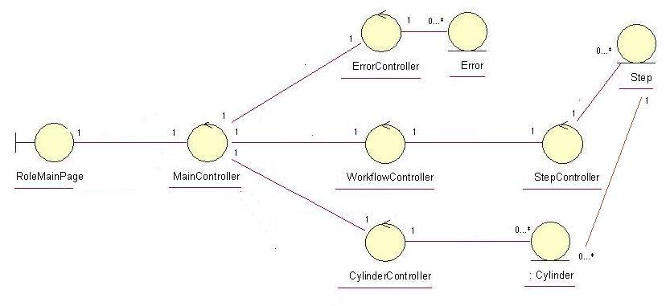

Derived Requirements
The Operation Manager PC keyboard and mouse or barcode scanner will be used to enter process steps information details (if any) and view all the system responses.

